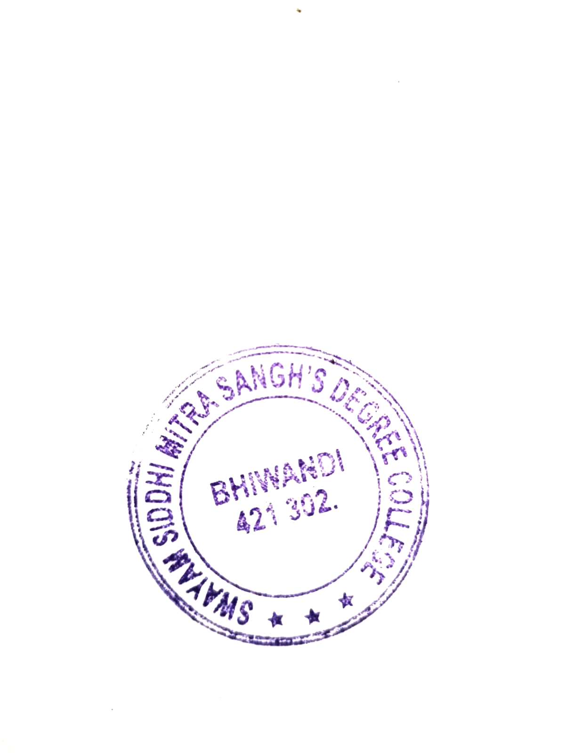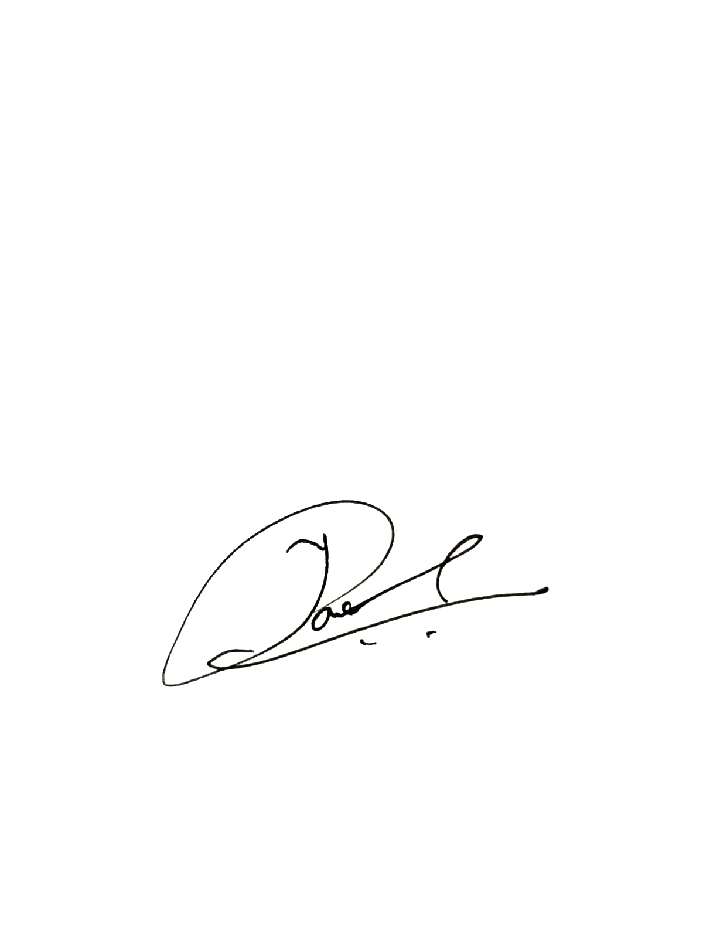

2.2.2 Student: Full Time Students Ratio YEAR 2022-23
Sr. No. | YEAR 2022-  23 | No. Of Students | No. Of Teachers | Students Teachers Ratio
1 | BCOM | 850 | 21 | 40/1
2 | BMS | 471 | 9 | 52/1
3 | BSC (HS) | 0 | 0 | 0
4 | BCOM (TM) | 0 | 0 | 0
5 | M.COM | 47 | 4 | 12/1

2.2.2 Student:Full Time Students Ratio YEAR 2021-2022
YEAR 2020-2021 | No. Of Students | No. Of Teachers | Students Teachers Ratio
FYBCOM | 306 | 5 | 61/1
SYBCOM | 229 | 5 | 46/1
TYBCOM | 230 | 5 | 46/1
FYBMS | 151 | 4 | 38/1
SYBMS | 145 | 4 | 36/1
TYBMS | 138 | 4 | 35/1
FYBSC (HS) | 0 | 0 | 0
SYBSC (HS) | 0 | 0 | 0
TYBSC (HS) | 2 | 2 | 1/1
FYBCOM (TM) | 0 | 0 | 0
SYBCOM (TM) | 0 | 0 | 0
TYBCOM (TM) | 0 | 0 | 0


2.2.2 Student:Full Time Students Ratio YEAR 2020-2021
YEAR 2020-2021 | No. Of Students |  | No. Of Teachers |  | Students Teachers Ratio
FYBCOM | 282 |  | 5 |  | 57/1
SYBCOM | 231 |  | 5 |  | 46/1
TYBCOM | 188 |  | 5 |  | 38/1
FYBMS | 176 |  | 4 |  | 44/1
SYBMS | 152 |  | 4 |  | 38/1
TYBMS | 131 |  | 4 |  | 33/1
FYBSC (HS) | 0 |  | 0 |  | 0
SYBSC (HS) | 16 |  | 2 |  | 8/1
TYBSC (HS) | 0 |  | 0 |  | 0
FYBCOM (TM) | 0 |  | 0 |  | 0
SYBCOM (TM) | 0 |  | 0 |  | 0
TYBCOM (TM) | 0 |  | 0 |  | 0

2.2.2 Student:Full Time Students Ratio YEAR 2019/20
YEAR 2020-2021 | No. Of Students |  | No. Of Teachers |  | Students Teachers Ratio
FYBCOM | 287 |  | 10 |  | 29/1.
SYBCOM | 233 |  | 10 |  | 23/1.
TYBCOM | 217 |  | 10 |  | 22/1.
FYBMS | 204 |  | 8 |  | 26/1.
SYBMS | 184 |  | 8 |  | 23/1.
TYBMS | 148 |  | 8 |  | 19/1.
FYBSC (HS) | 43 |  | 2 |  | 22/1.
SYBSC (HS) | 12 |  | 6 |  | 3/2.
TYBSC (HS) | 0 |  | 0 |  | 0
FYBCOM (TM) | 0 |  | 0 |  | 0
SYBCOM (TM) | 0 |  | 0 |  | 0
TYBCOM (TM) | 0 |  | 0 |  | 0

2.2.2 Student:Full Time Students Ratio YEAR 2018-19
YEAR 2020-2021 | No. Of Students |  | No. Of Teachers |  | Students Teachers Ratio
FYBCOM | 270 |  | 10 |  | 27/1.
SYBCOM | 230 |  | 10 |  | 23/1.
TYBCOM | 131 |  | 10 |  | 13/1.
FYBMS | 198 |  | 8 |  | 25/1.
SYBMS | 154 |  | 8 |  | 19/1.
TYBMS | 136 |  | 8 |  | 17/1.
FYBSC (HS) | 22 |  | 2 |  | 11/1.
SYBSC (HS) | 0 |  | 0 |  | 0
TYBSC (HS) | 0 |  | 0 |  | 0
FYBCOM (TM) | 0 |  | 0 |  | 0
SYBCOM (TM) | 0 |  | 0 |  | 0
TYBCOM (TM) | 0 |  | 0 |  | 0

